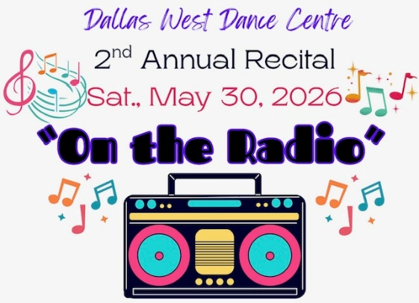

RECITAL ORDER
2026

FIRST HALF – 10:00 a.m.
- Come Sail Away
- If All the Raindrops
- Party in the U.S.A.
- Fire on Fire
- The Girls
- Take to the Sky
- Pure Imagination
- Trolls Mashup
- 9 to 5
- It’s a Beautiful Morning
- For Good
- Gift of a Friend
- Older
- Dance Dance Dance
- Around the World
- Material Girl
- Dancing Queen
- Radio Hits Medley
- Time After Time
- Don’t Stop Believin’
- Be Our Guest
- Burning Love - Juniors
- It Takes Two
- Fabulous
- Boogie Wonderland
- Keep Breathing
- Firework
- Daddy-Daughter Group 1
- Wipeout

SECOND HALF – 12:45
- Vogue
- Taylor Swift Medley
- Sing a Song
- I Was Here
- California Sun
- Party’s Just Begun
- Burning Love – Teens
- Rockin’ Robin
- Part of Your World
- Singin’ in the Rain
- I Feel Like Dancing
- Walking on Sunshine
- Somewhere Over the Rainbow
- Move Your Feet
- Surfer Girl
- Huntrix
- Hand to Hold
- Latch
- The Schuyler Sisters
- Performance Team
- Move it Like This
- Rainbow
- You Can’t Stop the Beat
- Rainbow Connection
- Le Jazz Hot
- A Fifth of Beethoven
- Daddy-Daughter Group 2
- Unchained Melody
- Shake it Off
- Remix

