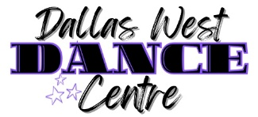
The Nutcracker Ballet
Workshop & Auditions
July 13-16, 2026

Workshop Schedule:
Mon., July 13, 10:00-12:00 - ages 7-10
Tues., July 14 & Wed., July 15, 10:00-12:00 - ages 11+

Audition Schedule:
Thur., July 16
10:00-11:00 – Ages 7-10
11:00-12:30 – Ages 11+

Cost:
$40.00/day

Prerequisites:
- Dancers must have a minimum of one year of ballet training the year previous to auditions. We strongly recommend at least two years of ballet just prior to auditions.
- Dancers must be enrolled in at least one level II or III ballet class at DWDC.
Auditions Info:
- All DWDC fall ballet classes will have the opportunity to perform in our Nutcracker production with their classes. (Details coming this summer.)
- Auditions are held for level II & III dancers interested in performing main roles, solos, duos, and trios.
- Dancers may attend the workshop and not audition or audition for the experience only.
- Dancers who audition must attend the workshop.
- DRESS CODE: black leotard, pink tights, pink ballet shoes, hair in a bun and out of face, no jewelry; optional - ballet skirt, leg warmers, ballet sweaters/shrugs (pink or black)
Registration options:
- Contact our office
- through your parent portal
- registration link on our website: www.dallaswestdance.com

Please feel free to contact us with questions!
info@dallaswestdance.com

